**Ειδικά Προγράμματα**

**Αμερικανικός Πολιτισμός στη** **Νέα Υόρκη**

για μαθητές και μαθήτριες 13 - 17 ετών

6 – 17 Ιουλίου 2025

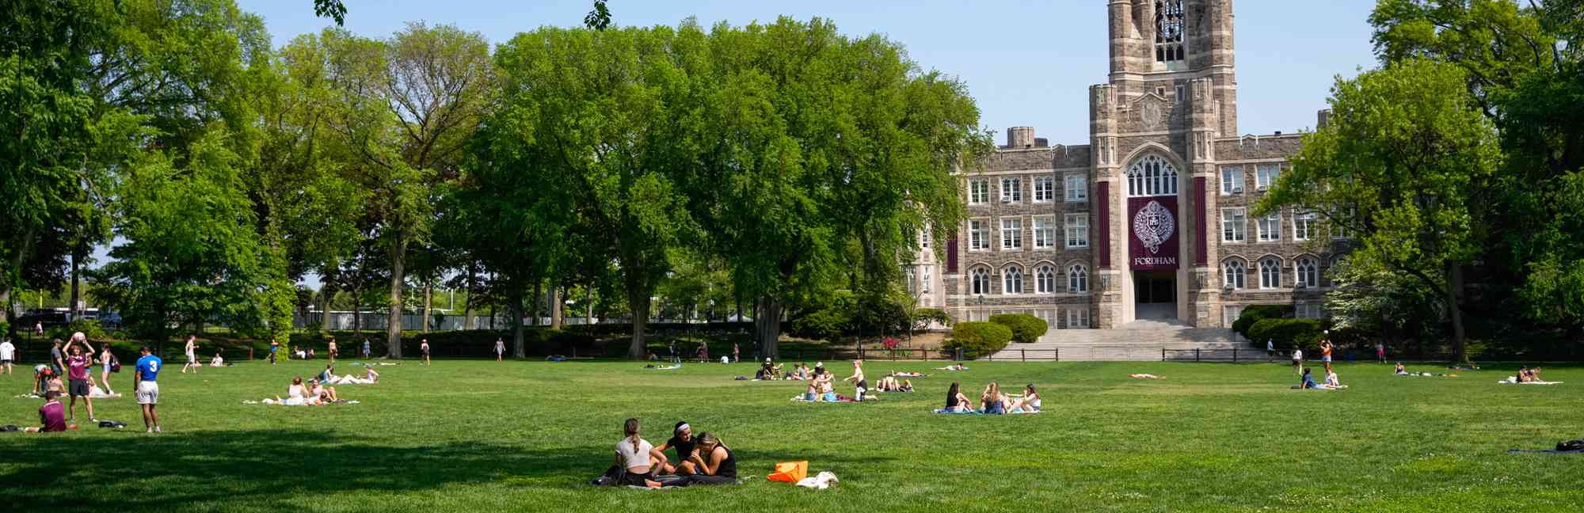

**Πτήσεις: Emirates**

Flight EK 209 Κυριακή 06 Ιουλίου 2025 ATHEWR 17:35 - 21:20

Flight EK 210 Πέμπτη 17 Ιουλίου 2025 EWRATH 00:05 - 16:05

Μεταφορά από/προς αεροδρόμιο και για μονοήμερες εκδρομές με ιδιωτικό λεωφορείο. Υπόλοιπες μεταφορές, π.χ. στο κέντρο του Μανχάταν, με τρένο και subway.

**Διαμονή:**  Rose Hill Campus - Fordham University- Μπρόνξ, Νέα Υόρκη σε μονόκλινα δωμάτια σε διαμέρισμα των 4 ατόμων. Το campus είναι περιφραγμένο και έχει 24/7 φύλαξη.

**Μαθήματα Αμερικανικού Πολιτισμού στα Αγγλικά (12 ώρες/δύο ημέρες):**

Δομημένα μαθήματα που εστιάζουν στα λεξιλόγιο και τις δεξιότητες συνομιλίας, ενδεικτικά:

**Πολιτιστικά Εργαστήρια:** Δραστηριότητες όπως εκμάθηση παραδοσιακών χορών και εξερεύνηση πολιτιστικών παραδόσεων.

**Γλωσσικά Παιχνίδια**: Διασκεδαστικά παιχνίδια που ενθαρρύνουν την ομιλία και την ακρόαση στη αγγλική γλώσσα.

**Δημιουργικά Έργα**: Ενθάρρυνση των μαθητών να δημιουργήσουν σκετς, βίντεο ή παρουσιάσεις στη αγγλική γλώσσα.

**Αθλήματα και Παιχνίδια**: Ενσωμάτωση της γλωσσικής μάθησης σε αθλήματα και υπαίθριες δραστηριότητες.

**Εξερεύνηση της Φύσης**: Διδασκαλία της γλώσσας μέσω περιπάτων στη φύση και περιβαλλοντικής εκπαίδευσης.

**Πολιτιστική Έκθεση**: Οι μαθητές παρουσιάσουν όσα έμαθαν μέσω παραστάσεων, εκθεμάτων και παρουσιάσεων.

**Πιστοποιητικά Γλώσσας**: Απονομή πιστοποιητικών για την αναγνώριση των επιτευγμάτων των μαθητών μας.

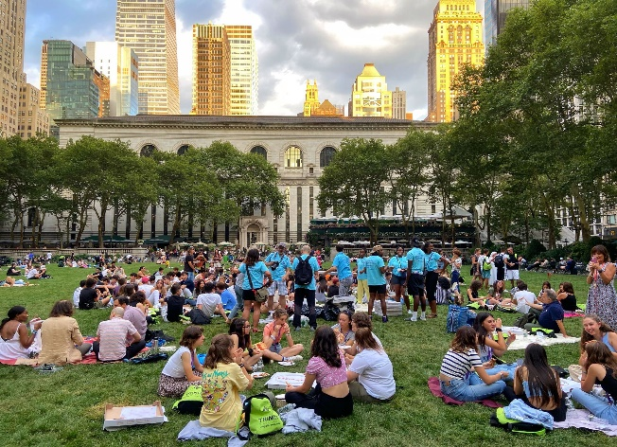**Εκδρομές**

* Metropolitan Museum of Art
* MoMA (Museum of Modern Art)
* American Museum of Natural History
* Statue of Liberty & Ellis Island
* Wall street
* The Bull & 9/11 Monument
* Empire State Building
* United Nations
* Chelsea market
* Greenwich Village
* 5th Avenue & Times Square
* Staten Island – Manhattan
* Brooklyn Bridge
* Summit One Vanderbilt
* Coney Island
* Central Park
* High Line
* Major League Baseball game
* Bronx Botanical Gardens & the Zoo
* Hard Rock Cafe
* Bubba Gump

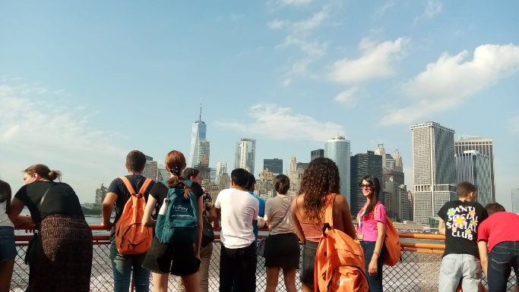 **Αθλητικές δραστηριότητες**

Αθλητικές δραστηριότητες στο Campus – Rose Hill

**Βραδινές Δραστηριότητες**

* Music Night
* Movie Night
* Party Night

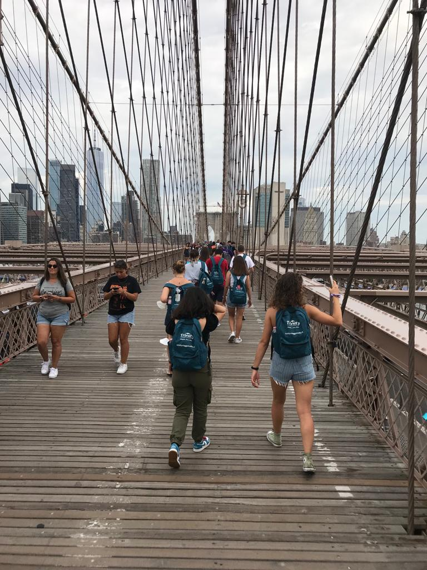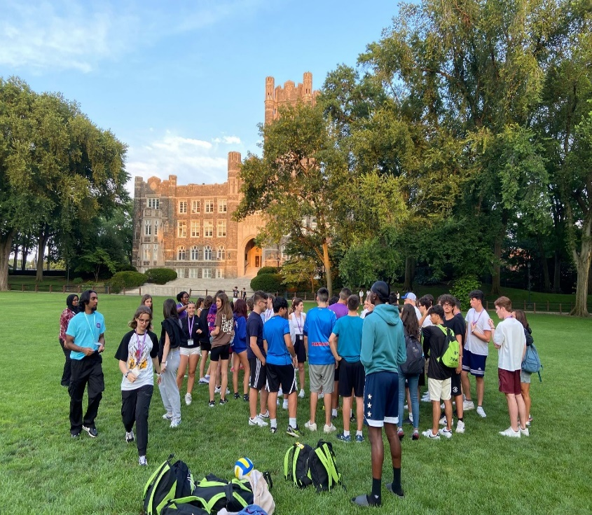

**Κανόνες Φοιτητικής Εστίας του Fordham University και του εκπαιδευτικού οργανισμού TIE**

“**Conduct & Expulsion**

Students must conduct themselves within the law of the School’s jurisdiction and Students must also comply with the School’s rules, regulations and policies as stated on our [Website](https://www.fordham.edu/student-life/deans-of-students-and-student-life/student-handbook/university-regulations/a---z-listing/university-code-of-conduct/), posted at the School or otherwise disseminated before or on the Student’s arrival, or at any other time during the Programme or Course.

TIE have a Student Code of Conduct posted on the [Website](https://trinityinted.com/student-code-of-conduct/) which Students are required to read prior to arrival and follow during the Programme or Course.

A Student or Group Leader or group of Students may be asked to leave or be expelled without receiving any refund of fees if they:

* • continually break the Student Code of Conduct
* • commit or are involved in, or suspected of any criminal activity in the jurisdiction of the School
* • give false or misleading information when supplying TIE with information about their application, including any omission of medical or health information that may lead to extra costs or resources incurred by TIE
* • act in a way that might bring the reputation of TIE or the venue School into disrepute

All costs and expenses relating to an expulsion shall be paid for by the Student.

TIE expects its staff to be treated with respect and TIE expects its staff to treat Students, Group Leaders and any other servant of TIE with respect.

Where a Student refuses to pay for these extra costs or be unwilling to be expelled, the Student will be accompanied to the nearest Embassy or Consulate for their government to manage the Student.”

**Συνοπτικές Πολιτικές Ταξιδιωτικής Ασφάλειας**

What is this type of insurance?

**Travel Insurance**

**Insurance Product Information Document**

**Company: White Horse Insurance UK Limited, a Branch of White Horse Insurance Ireland dac**

White Horse Insurance UK Limited is registered in England and Wales. White Horse Insurance Ireland dac is registered in Ireland. White Horse Insurance UK Limited is authorised by the Prudential Regulation Authority and regulated by the Financial Conduct Authority. Firm reference number 203320.

**Product:** Multirisk Plus Cancellation - guard.me

This document is intended to provide a summary of the main cover and exclusions of your travel insurance policy. It provides general information only – you will receive a copy of the full terms and conditions of your cover.

This policy is a medical expenses travel insurance policy that provides cover for each insured person as summarised under “What is insured?” below.



**What is insured?**

* Cancellation or Curtailment
  + Rearrangement
  + Abandonment
  + Cancellation
  + Curtailment
* Delayed Departure
* Missed Departure
* Baggage Delay
* Baggage, Personal Money and Travel Documents
* Emergency Medical, Repatriation and Other Expenses
  + Emergency Medical Assistance
  + Repatriation Expenses
  + Funeral Expenses or Burial Costs
  + Emergency Dental Expenses
* Hospital Benefit
* Personal Accident and Public Transport Accident
* Personal Liability
  + Bodily Injury, Death or Illness
  + Accidental Loss of or Damage to Property
* Death During a Trip



**What is not insured?**

**🞫** Your travel to a country, specific area or event to which the government of your country of temporary residence or other regulatory authority in a country in which you are travelling to/from has issued travel restrictions.

**🞫** Existing medical conditions or failing to keep to the terms of the ‘Important Conditions Relating to Health’ section.

**🞫** You travelling against professional medical advice or would be travelling against the advice of a medical practitioner had you asked their advice.

**🞫** Your wilfully, self-inflicted injury or serious illness, sexually transmitted diseases, solvent abuse, alcohol abuse or your alcohol dependency or drug use (other than

drugs taken in accordance with treatment prescribed and directed by a medical practitioner, but not for the treatment of drug addiction or alcohol dependency).

**🞫** Circumstances known to you before the policy purchase date or booking any trip which could reasonably have been expected to lead to a claim.

**🞫** You failing to obtain, hold, produce or maintain the required immigration, work, residence or similar visas, permits or documents.

**🞫** Pandemic or epidemic unless specifically listed as covered.

**🞫** Any claim that occurs outside of your period of insurance.

**🞫** Your self-exposure to needless peril.

**🞫** Your own unlawful action or any criminal proceedings against you or any loss or damage deliberately carried out or caused by you.

**🞫** Deliberate exposure to danger except in an attempt to save human life.

**🞫** Using a motorised vehicle unless you have a full and valid current driving licence that permits the use of such vehicles.

**🞫** Any sport or activity unless listed under the Sports and Activities section.

**🞫** Manual work or any professional sports or professional entertaining.

**🞫** Baggage, money or valuables left unattended.



**Are there any restrictions on cover?**

**!** The insured person must be an international student (or their immediate family and/or their group leader travelling with the international student) attending an international programme on a trip.

**!** You must hold a valid visa for the full duration of the period of insurance.

**!** You must be under 75 years old on the Cover Start Date of the period of insurance.

**!** You must comply with the Important Conditions Relating to Health section to have the full protection of your policy. There is no cover under this policy for any existing medical condition(s) not listed in the list of acceptable medical conditions in the policy wording.

**!** You must take all reasonable precautions to avoid bodily injury, serious illness, loss, theft or damage.

**!** If you purchase this insurance policy after leaving your home country while already on your trip and/or your trip has already started, there is a mandatory 14-day waiting period following the purchase date, during which no coverage applies.

**!** Cover under Section A – Cancellation or Curtailment is provided for specific circumstances only and as stated in the policy wording.

C:\Users\GMorrison\AppData\Local\Microsoft\Windows\Temporary Internet Files\Content.Word\IPID_money.jpg 

**Travel Insurance**

**Insurance Product Information Document**

**Company: White Horse Insurance UK Limited, a Branch of White Horse Insurance Ireland dac**

White Horse Insurance UK Limited is registered in England and Wales. White Horse Insurance Ireland dac is registered in Ireland. White Horse Insurance UK Limited is authorised by the Prudential Regulation Authority and regulated by the Financial Conduct Authority. Firm reference number 203320.

**Product:** Multirisk Plus Cancellation - guard.me



**Where am I covered?**

* Trips: You are covered for trips made to your country of temporary residence where you are undertaking your international programme.
* Holidays: You are covered for holidays within or outside your country of temporary residence up to a maximum duration of up to 21 days per holiday, which begins and ends within the period of insurance.

|  |
| --- |
| C:\Users\GMorrison\AppData\Local\Microsoft\Windows\Temporary Internet Files\Content.Word\IPID_handshake.jpg  **What are my obligations?**   * Claim notification should be made as soon as possible after any bodily injury, serious illness, disease, incident, event, redundancy or the discovery of any loss, theft or damage which may lead to a claim under this policy. * If you suffer a serious illness or bodily injury which leads to you being an inpatient in hospital or before any arrangements are made for repatriation, you must contact the Emergency Assistance Service. * You must take all reasonable precautions to avoid injury, serious illness, disease, loss, theft or damage and take all reasonable steps to safeguard your property from loss or damage and to recover any lost or stolen property. * You must take care to answer all questions honestly and to the best of your knowledge. You must not make any misrepresentation of a fact that could influence us in accepting this insurance. * If, at the time of any incident which results in a claim under this policy, there is another insurance covering the same loss, damage, expense or liability, then you must disclose this to us at the time of submitting a claim. * You must provide all necessary documentation requested by us at your expense. If you do not provide this any claim may be refused. * You must not admit, deny, settle, reject, negotiate or make any arrangement for any claim without our permission. |
| **When and how do I pay?**  The premium is due immediately on the issue date of the insurance policy. The premium must be paid directly to your school, institution or agency only, as the policyholder. |
| C:\Users\GMorrison\AppData\Local\Microsoft\Windows\Temporary Internet Files\Content.Word\IPID_egg_timer.jpg  **When does the cover start and end?**  Section A – Part 1: Rearrangement, Cancellation or Abandonment cover commences on the issue date on the most recent certificate of insurance.  All other cover under this policy commences on the Cover Start Date as stated on the certificate of insurance or when you depart your home country to commence your trip, whichever is later.  All cover automatically ends on the earliest occurrence of a below listed event (whichever event is sooner):   1. the cover end date as shown on the insured person(s) most recent certificate of insurance; or 2. the insured person(s) no longer meets the eligibility criteria; or 3. the insured person(s) visa is revoked or has expired; or 4. the insured person(s) period of insurance has expired; or 5. following emergency repatriation to the insured persons home country; or 6. we no longer underwrite this policy. |
| **How do I cancel the contract?**  Cancellation by the insured person applies as follows:  **Cancellation within 14 working days of the purchase date:**  You may not cancel this policy, however, you may choose to end your cover and your entitlements to all benefits under this policy by writing to the policyholder within 14 working days of the purchase date. Please contact the policyholder for a premium refund providing you have not travelled, and no claim has been made or is intended to be made and no incident likely to give rise to a claim has occurred.  **Cancellation after 14 working days of the purchase date:**  You may choose to end your cover and your entitlements to all benefits under this policy by writing to the policyholder 14 working days after the purchase date. If you cancel outside of the terms of the Statutory Cancellation Rights, referenced above, the policyholder will not receive a premium refund. |